Project Selection for Construction Businesses in Indonesia Using AHP: A Case of CV. Maezurra Indotama

Shafa Dwidiva Maharani^{1*}, Manahan Parlindungan Saragih Siallagan²

^{1*,2} School of Business and Management, Institut Teknologi Bandung, Indonesia

Corresponding Author: shafa_dwidiva@sbm-itb.ac.id^{1*)}

Keywords : Analytical Hierarchy Process (AHP), Project Selection, Construction Sector Challenges | Abstract: The construction industry is the backbone of Indonesia's economy but needs operational inefficiencies like slow payment processes and a complicated bureaucratic structure. The research applies AHP to analyze the project selection criteria of small firms in the particular case of CV. Maezurra Indotama. Key decision criteria were identified through expert interviews and pairwise comparisons contract management, fund security, and schedule management. The findings indicate the high importance of contract review periods at 42.2%, client's fund availability at 47.0 %, and payment scheduling at 29.1%. The School Renovation Project came out as the most preferred option, aligned with the strategic focus. Suggestions and the way forward include enhancement of contract management through standard templates, preparation of adequate funds, and setting reasonable timelines. With these attributes in place, competitive growth of the construction sector will be achieved.

Introduction
Contributions from various business sectors support economic growth in Indonesia. The construction sector is one of the business sectors that provides the fourth most significant contribution. According to data from Badan Pusat Statistik (BPS) Indonesia, in the first quarter of 2024, the construction sector in Indonesia contributed 10.23% to the Gross Domestic Product (GDP). Previously, in 2023, the construction sector contributed 9.92% to Gross Domestic Product (GDP). This growth shows that the construction sector in Indonesia has a positive trend from year to year.

Figure 1. Distribution and Growth of GDP by Field of Business
Indonesia Quarterly Gross Domestic Product 2020–2024, Volume 7 2024
Source: Badan Pusat Statistik (BPS) Indonesia

The construction sector's contribution to GDP fluctuated over two years, peaking at 10.48% in Q4 2021 before declining to 9.49% in Q3 2022 and recovering to 10.49% in Q4 2023. Seasonal peaks in Q4 highlight strong year-end activity. Driven by infrastructure spending aligned with RPJMN and Law No. 2/2017, small-scale projects in rural areas remain vital. However, bureaucratic inefficiency persists, with the Construction Business Problem Index scoring 8.19 in Q1 2023-2024, indicating cash flow delays caused by contract non-compliance.
While Article 55 of Law No. 2/2017 regulates cost responsibilities, its flexibility often causes disputes over unclear mechanisms. Small firms, such as CV. Maezurra Indotama, face payment delays and lack clarity in project selection, contributing to performance declines in 2024. Though studies cite financial and operational challenges (Frimpong et al., 2003; Ahmad et al., 2022), strategies for project selection remain underexplored. Addressing these issues requires streamlined administration, clearer guidelines, and regulatory improvements to sustain efficiency and business growth. This study explores practical solutions to these challenges.

Research Method
Mixed-method research combines qualitative and quantitative approaches, offering a holistic understanding of business issues while mitigating the limitations of single methods (Creswell & Plano Clark, 2018). Qualitative insights address business problems, while quantitative methods, like the Analytical Hierarchy Process (AHP), systematically rank criteria for decision-making (Tashakkori & Teddlie, 2010). This study examines late payment issues in the construction sector through a case study of CV. Maezurra Indotama, a government contractor. Using AHP, expert interviews provided qualitative insights, while pairwise comparisons quantified criteria, validated by consistency ratios (Saaty, 2008). A literature review highlights AHP’s role in addressing financial risks, contract management, and project selection (Love et al., 2018). AHP's structured process prioritizes decision-making, resource allocation, and risk management, proving effective across industries like ICT and construction performance evaluations (Wang & Yang, 2007; Skibniewski & Chao, 1992).

Result and Discussion
Development of Decision Hierarchy
The initial stage of developing a decision hierarchy involves identifying the main challenges faced by the organization to formulate relevant criteria and sub-criteria. This hierarchy is designed through in-depth interviews with key stakeholders, such as the Person in Charge (PIC), and reviews of scientific references to ensure reliability and a solid academic basis. The process includes four key steps, analyzing the problem to identify critical issues, determining criteria and sub-criteria through interviews and literature, constructing a hierarchical structure with objectives at the top and detailed sub-criteria below, and validating the hierarchy through expert consultation or comparison with previous research. Reliable scientific journals and studies ensure that the hierarchy meets organizational needs and is academically supported.

Table 1. Development of Criteria
Criteria | Sub Criteria Source | Solution | Source
Poor Contract Management | Literature | Project has clear and simplified contract documents | (Frimpong et al., 2003; Ahmad et al., 2022)
 | Literature | Contract review period available before signing
 | PIC | The scope of work is clearly defined in the contract
Shortage of Funds from Client | Literature | Can ensure client funds are available | (Islam et al., 2014; Ahmad et al., 2022)
 | Literature | Clients can ensure additional financial support and guarantees are arranged in a timely manner
 | Literature | Shares of the project might be sold to get the financial support
Inadequate Scheduling | Literature | There are experts coming from the project client | (Pati and Kumar, 2015; Ahmad et al., 2022)
 | Literature | Realistic job scheduling and presented in advance
 | Literature | Not too many restrictions for project supervision
 | Literature | Scheduling of term payments is clearly guaranteed by the client

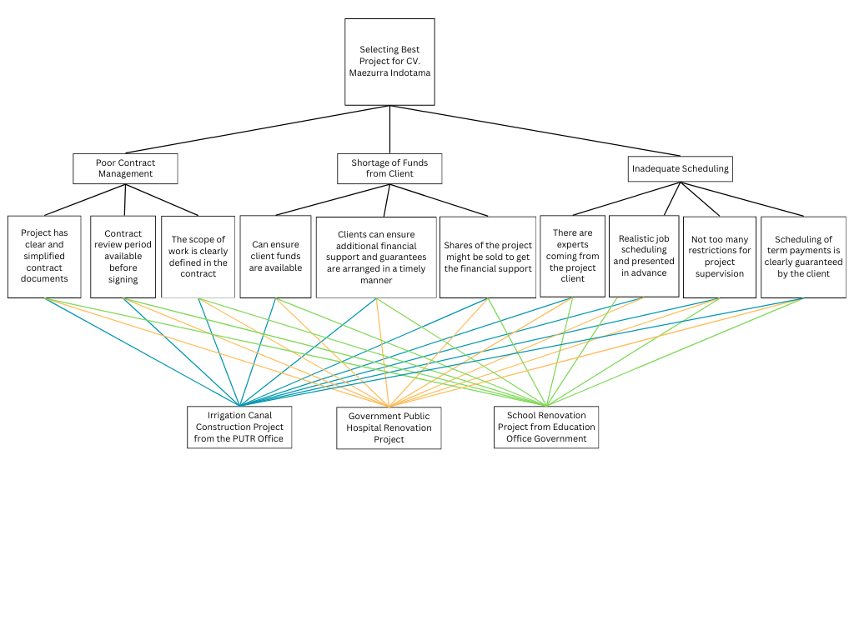
Poor contract management is a significant challenge in project implementation as it can create uncertainty and conflicts. Solutions include designing clear and straightforward contract documents, allowing sufficient time for review to identify issues, and ensuring the scope of work is clearly defined to avoid ambiguity (Frimpong et al., 2003; Ahmad et al., 2022). Another critical issue is the need for more funds from the client, which can disrupt project continuity. Literature suggests ensuring funds are available before the project begins, arranging additional financial support promptly, or selling project shares to secure financing (Islam et al., 2014; Ahmad et al., 2022). Lastly, inadequate scheduling often leads to delays. Solutions include involving client-side experts in schedule planning, preparing realistic schedules before the project starts, reducing supervision restrictions for flexibility, and ensuring a clear term payment schedule to prevent funding delays (Pati & Kumar, 2015; (Ahmad et al., 2022)
Figure 2. Decision Hierarchy on Selecting the Best Construction Project

The decision hierarchy for CV. Maezurra’s project selection focuses on three main criteria: Poor Contract Management, Shortage of Funds from Clients, and Inadequate Scheduling, each with practical sub-criteria. For Poor Contract Management, key solutions include clear contract documents, a review period before signing, and a well-defined scope of work to avoid ambiguity. Shortage of Funds emphasizes securing funds before projects begin, arranging financial guarantees, and selling project shares if necessary. For Inadequate Scheduling, expert involvement ensures realistic schedules, flexible supervision, and clear-term payment schedules to prevent delays. These criteria are applied to three projects: Irrigation Canal Construction (PURB Office), Government Public Procurement of Equipment, and School Renovation Project (Education Office). This evaluation aligns projects with strategic goals, ensuring the best fit for the company.

Analysis of Pairwise Comparison for Criteria and Sub-Criteria

Outcome of Pairwise Comparison for Criteria
In the Analytical Hierarchy Process (AHP), the Consistency Ratio (CR) measures the consistency of pairwise comparisons. According to Saaty, a CR value ≤ 0.10 indicates consistency, while values above 0.10 suggest inconsistency, requiring a review of the comparison matrix.

Table 2. Group Result and Priorities of Individual Participants
Participant | Quality of Contract Management | Secured Funds | Schedule Management | CR_{max}
Group result | 35.6% | 30.8% | 33.6% | 1.4%
Project Supervisor | 44.4% | 8.4% | 47.2% | 0.4%
Operational Director | 9.4% | 80.9% | 9.7% | 0.2%
Finance Director | 55.8% | 12.2% | 32.0% | 1.9%
Director | 26.0% | 41.3% | 32.7% | 5.6%

The analysis prioritized three main criteria: Quality of Contract Management, Secured Funds, and Schedule Management, with group and individual variations. At the group level, Quality of Contract Management ranked highest (35.6%), followed by Schedule Management (33.6%) and Secured Funds (30.8%), with a reliable consistency ratio (CRmax 1.4%). Individually, the Project Supervisor prioritized Schedule Management (47.2%), while the Operational Director emphasized Secured Funds (80.9%). The Finance Director ranked Quality of Contract Management highest (55.8%), and the Director presented a balanced view, prioritizing Secured Funds (41.3%). All assessments maintained acceptable consistency, ensuring validity. The results highlight that Quality of Contract Management (35.6%) is most crucial, with contract reviews, fund availability, and clear payment schedules identified as key factors for project success at CV. Maezurra Indotama.

Outcome of Pairwise Comparison for Sub Criteria
Contract Management
The figure below provides a detailed explanation of the paired comparisons conducted for the sub-criteria related to Contract Management:

Table 3. AHP Group Result for Sub-criteria of Contract Management
Participant | Project has clear and simplified contract | Contract review period available before sign | The scope of work is clearly defined | CR_{max}
Group result | 31.4% | 42.2% | 26.4% | 0.0%
Project Supervisor | 69.1% | 14.9% | 16.0% | 0.6%
Operational Director | 20.0% | 68.3% | 11.7% | 2.6%
Finance Director | 17.4% | 19.2% | 63.4% | 1.0%
Director | 16.7% | 66.7% | 16.7% | 0.0%

The results of the table analysis show the distribution of priorities in the three main sub-criteria in Quality of Contract Management: the Project has clear and simplified contract documents, the Contract review period is available before signing, and The scope of work is clearly defined in the contract, with varying levels of consistency (CRmax) among participants. At the individual level, priorities varied among participants. The Project Supervisor focused on clear and simplified contract documents (69.1%) with excellent consistency (CRmax 0.6%). The Operational Director emphasized the contract review period before signing (68.3%) with acceptable consistency (CRmax 2.6%). The Finance Director prioritized a clearly defined scope of work (63.4%) with good consistency (CRmax 1.0%). The Director evenly weighted all sub-criteria, favoring the contract review period (66.7%) with perfect consistency (CRmax 0.0%). Overall, the group results highlight the contract review period before signing as the top priority (42.2%), followed by clear and simplified contract documents (31.4%) and a clearly defined scope of work (26.4%). The perfect group consistency ratio (CR 0.0%) ensures reliable and valid results, emphasizing the contract review period as the most critical factor in effective contract management.

Secured Funds
The figure below provides a detailed account of the pairwise comparison conducted for the sub-criteria associated with Secured Funds:

Table 4. AHP Group Result for Sub-criteria of Secured Funds
Participant | Can ensure client funds are available | Clients can ensure additional financial support | Shares of the project might be sold to get th | CR_{max}
Group result | 47.0% | 28.5% | 24.5% | 1.0%
Project Supervisor | 41.3% | 32.7% | 26.0% | 5.6%
Operational Director | 23.2% | 18.4% | 58.4% | 5.6%
Finance Director | 43.3% | 46.6% | 10.0% | 0.6%
Director | 71.4% | 14.3% | 14.3% | 0.0%

The group results for the Secured Funds category show that the sub-criterion “Can ensure client funds are available” ranks highest (47.0%), emphasizing the importance of securing funds before starting a project. “Clients can provide additional financial support” ranks second (28.5%), highlighting the role of supplementary financial guarantees, while “Shares of the project might be sold” ranks third (24.5%), reflecting alternative funding options. The group consistency ratio (CRmax 1.0%) confirms reliable and valid results, with securing client funds identified as the most critical factor for project success.

Schedule Management
The figure below provides a detailed account of the pairwise comparison conducted for the sub-criteria associated with Schedule Management:

Table 5. AHP Group Result for Sub-criteria of Schedule Management
Participant | There are experts coming from the project cli | Realistic job scheduling and presented in adv | Not too many restrictions for project supervi | Scheduling of term payments is clearly guaran | CR_{max}
Group result | 24.3% | 19.4% | 27.1% | 29.1% | 0.5%
Project Supervisor | 50.4% | 21.3% | 21.8% | 6.5% | 1.3%
Operational Director | 50.6% | 21.5% | 15.3% | 12.6% | 2.2%
Finance Director | 7.0% | 10.4% | 34.5% | 48.1% | 4.1%
Director | 6.9% | 10.6% | 16.8% | 65.6% | 5.2%

The Schedule Management analysis prioritizes four sub-criteria with a high group consistency (CRmax 0.5%). The top priority is “Scheduling of term payments is guaranteed” (29.1%), stressing the importance of clear and reliable payment schedules. “Few restrictions for project supervision” ranks second (27.1%), emphasizing the need for supervisory flexibility. Third is “Experts come from the project client” (24.3%), highlighting client expertise, while “Realistic job scheduling” (19.4%) ranks fourth, showing its lower relative importance.
In the overall decision hierarchy, the top global priority is the “Contract review period available before signing” (15.0%), followed by “Ensuring client funds are available” (14.5%), “Scheduling of term payments guaranteed” (9.8%), and “Few restrictions for project supervision” (9.1%). These priorities underline the importance of contract readiness, financial assurance, payment clarity, and supervisory flexibility in selecting the best project for CV Maezurra Indotama.

Outcome of Pairwise Comparison for Sub Criteria With Alternative
In the second phase, the same group of experts completed a paired comparison to assess the importance of each criterion. Rankings for factors related to alternatives were then weighted and multiplied by their respective criteria, generating a priority index that indicates how well each alternative aligns with the sub-criteria.

Table 6. Alternatives by Participants
Participant | Irrigation Canal Construction Project | Government Public Hospital Renovation Project | School Renovation Project | CR_{max}
Group result | 32.4% | 33.6% | 34.0% | 1.3%
Project Supervisor | 29.3% | 22.3% | 48.4% | 5.6%
Operational Director | 43.6% | 34.7% | 21.7% | 3.0%
Finance Director | 23.9% | 36.8% | 39.3% | 3.0%
Director | 32.1% | 37.1% | 30.8% | 5.6%

The analysis shows that the School Renovation Project is the top priority for CV Maezurra Indotama with a weight of 34.0%, followed by the Government Public Hospital Renovation Project (33.6%) and the Irrigation Canal Construction Project (32.4%). The group consistency level (CRmax 1.3%) confirms reliable results, though individual preferences varied, emphasizing the need to balance group and individual perspectives in decision-making.

Discussion
The analysis reveals that among the three main criteria for selecting the best project for CV Maezurra Indotama, Quality of Contract Management holds the highest weight (35.6%), followed by Schedule Management (33.6%) and Secured Funds (30.8%). Key sub-criteria include the contract review period before signing (15.0%) and ensuring client funds are available (14.5%), highlighting their critical role in minimizing risks and securing financing. In Schedule Management, guaranteed term payments (9.8%) and flexible supervision are prioritized for ensuring smooth execution.

Table 7s. Alternatives by Participants
Criteria | Weight (%) | Top Sub-Criteria | Weight (%)
Contract Management | 35.6% | Contract Review Period | 42,20%
Secured Funds | 30,8% | Client Fund Availability | 47,00%
Schedule Management | 33,6% | Scheduling of Term Payments | 29,10%

These findings align with Chan and Kumaraswamy (1997) on the importance of contract clarity but extend their conclusions using AHP for systematic prioritization. While group results favor the School Renovation Project, individual preferences vary, reflecting the need to balance group and individual priorities. Despite minor deviations, the high group consistency ratio ensures a reliable and robust decision-making process.

Business Solution
CV. Maezurra Indotama prioritizes projects with strong contract management, secure financial support, and effective schedule management, according to the weight analysis of criteria and sub-criteria. The study showed that School Renovation was the best choice and was given the highest priority during the group decision-making process.
Due to the clear and simplified contract management process, precise scheduling, and secured financial structure, the project aligns with the organization's strategic goals. These elements reduce operational risk and increase the likelihood that the project will be completed successfully. The proposed business solution involves selecting the School Renovation Project as the main focus and improving the operational approach in areas identified as critical. An increase in the project success rate, an improved contract review process, better scheduling, and guaranteed availability of funds are required. During the course of the project, incorporating feedback mechanisms and expert input will further streamline operations and reduce the likelihood of delays.

Conclusion
The Analytical Hierarchy Process (AHP) assesses the most favorable construction projects for CV. Maezurra Indotama, with the School Renovation Project being the strongest, with a 34% score. This score is based on three evaluation criteria: Quality of Contract Management, Fund Assurance, and Schedule Management. Critical sub-criteria include contract review periods, client funds assurances, and guaranteed project term payments. Efficient financial management, contract execution, and time parameters management are crucial for successful project delivery. The high consistency ratio indicates sound decision-making, making the AHP method an efficient choice for CV. Maezurra Indotama.

Recommendations
The ability of AHP to select the best project for CV, in this case, Maezurra Indotama, is shown in this study with the School Renovation Project as the priority. The contracted management, the financial part, and scheduling are the priority requirements for project success. Standardized contracts, the presence of funds, and proper scheduling will improve project performance. In future studies, it could be interesting to look at implementing dynamic AHP with some technological assistance to enhance decision-making efficiency.

References
Nugraha, P., Natan, I., & Sutjipto, R. (1986). Prosedur pembayaran dalam proyek konstruksi. Bandung: ITB Press.
Saaty, T. L. (1980). The analytic hierarchy process: Planning, priority setting, resource allocation. McGraw-Hill.
Ervianto, W. I. (2002). Manajemen proyek konstruksi. Yogyakarta: Andi Publisher.
Ervianto, W. I. (2003). Dasar-dasar manajemen proyek konstruksi. Yogyakarta: Andi Publisher.
Skibniewski, M. J., & Chao, L. C. (1992). Evaluation of advanced construction technology with AHP method. Journal of Construction Engineering and Management, 118(3), 577–593. https://doi.org/10.1061/(ASCE)0733-9364(1992)118:3(577)
Chan, A. P., & Kumaraswamy, M. M. (1997). A comparative study of causes of time overruns in Hong Kong construction projects. International Journal of Project Management, 15(1), 55–63. https://doi.org/10.1016/S0263-7863(96)00039-7
Ho, W. (2008). Integrated analytic hierarchy process and its applications – A literature review. European Journal of Operational Research, 186(1), 211–228. https://doi.org/10.1016/j.ejor.2007.01.004
Subramanian, N., & Ramanathan, R. (2012). A review of applications of analytic hierarchy process in operations management. International Journal of Production Economics, 138(2), 215–241. https://doi.org/10.1016/j.ijpe.2012.03.036
Miles, M. B., Huberman, A. M., & Saldaña, J. (2014). Qualitative data analysis: A methods sourcebook (3rd ed.). Sage Publications.
Law of the Republic of Indonesia Number 2 of 2017 concerning construction services. (2017). State Gazette of the Republic of Indonesia. Jakarta: Government of Indonesia.
Darko, A., Chan, A. P. C., Ameyaw, E. E., Owusu, E. K., & Pärn, E. A. (2018). Review of application of analytic hierarchy process (AHP) in construction. International Journal of Construction Management, 18(5), 436–452. https://doi.org/10.1080/15623599.2017.1321577
Love, P. E. D., Sing, C.-P., Wang, X., & Tam, C. M. (2018). Delays in construction projects: A global perspective. Built Environment Project and Asset Management, 8(1), 77–91. https://doi.org/10.1108/BEPAM-03-2017-0023
Mills, G. E., & Gay, L. R. (2019). Educational research: Competencies for analysis and applications (12th ed.). Pearson.
Presidential Regulation of the Republic of Indonesia No. 12 of 2021. (2021). Types of construction contracts. Jakarta: Government of Indonesia.
Badan Pusat Statistik. (2024). Distribution and growth of GDP by field of business. In Indonesia Quarterly Gross Domestic Product 2020–2024 (Vol. 7).
Badan Pusat Statistik. (2024). Government administration and bureaucracy in construction business problems. In Construction Indicators, 1st Quarter-2024.

